**Usecase Diagram:**

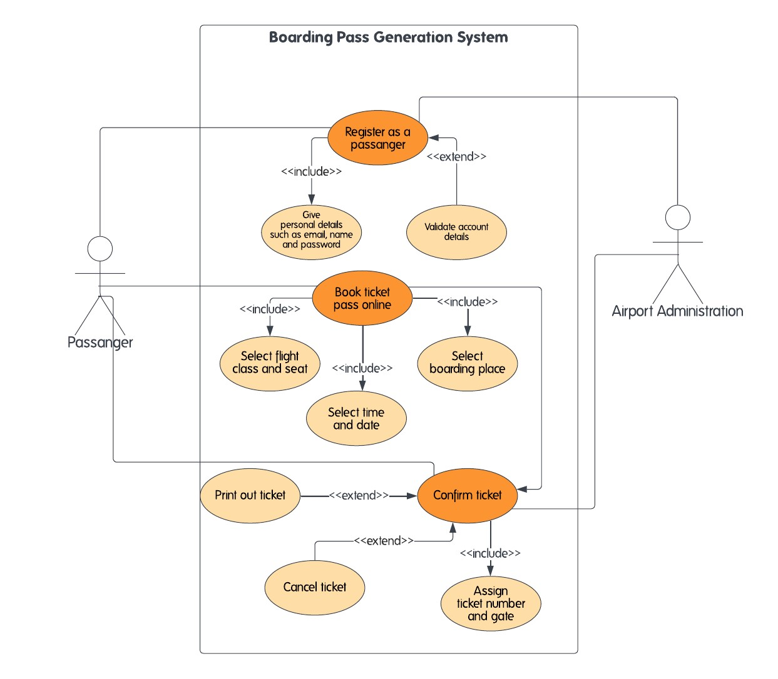

**Usecases:**

* Give personal details (includes email, name, and password)
* Select flight class and seat* Register as a passenger
* Print out ticket
* Book ticket pass online
* Select time and date
* Cancel ticket
* account details
* Select boarding place
* Confirm ticket
* Assign ticket number and

**Usecase description:**

* Give personal details: This use-case describes the process of providing personal information, including email, name, and password, when registering as a new passenger.
* Select flight class and seat: This use-case describes the process of selecting a flight class and seat assignment when booking a ticket.
* Register as a passenger: This use- describes the process of creating a new passenger account, which includes providing personal, selecting a flight, and confirming ticket details.
* Print ticket: This use-case describes the process of printing a physical ticket for a passenger, either at a self-service kiosk or at a check-in counter.
* Book ticket pass online: This use-case describes the process of booking a ticket online, which includes selecting a flight, class, and seat, providing payment information, and confirming ticket details.
* Select time and date: This use-case describes the process of selecting a time and date for a flight when booking a ticket.
* Cancel ticket: This use-case describes the process of canceling a ticket, either because the passenger has changed their plans or for some other reason.
* Validate account details: This use-case describes the process of verifying the accuracy of a passenger's account information, such as their name, email, and password.
* Select boarding place: This use-case describes the process of selecting a boarding place when booking a ticket, such as a specific airport or terminal.
* Confirm ticket: This use-case describes the process of confirming ticket details, such as the flight number, date, time, and seat assignment, before finalizing a booking.
* Assign ticket number and gate: This use-case describes the process of assigning a unique ticket number and gate information to a passenger's booking.

**Class Diagram:**

**Class description:**

The classes in this diagram include DomesticFlight, Flight, Seat, Passenger, and BoardingPass. The DomesticFlight class contains information about the aircraft type and the operating airline. The Flight class includes details about the flight number, departure and arrival airports, and date and time of departure. The Seat class contains information about the seat number and class type. The Passenger class includes information about the passenger's name, email, and password. The BoardingPass class contains details about the passenger, flight, seat, ticket number, gate, and boarding time.

In terms of relationships, the **DomesticFlight** class is the child class of **Flight**, which means it inherits the attributes of the parent class. Then, we have a one-to-many composition relationship between the **Flight** class and **Seat** class. One flight must have one to many seats in it.

Next, we have a one-to-many aggregation relationship between **Flight** and **Passenger** classes. A flight can have one to many passengers. **Passenger** and **BoardingPass** have a one-to-one association relationship. One passenger has a boarding pass to board a flight, so that's why it's a one-to-one relationship.